**Course 3 ML**

**Supervised**

**Classification :**target values are discrete (yes/no possible to devide)

**Regression :**target values are continuous (cost of house)

**Unsupervised** Find structure in unlabeled data

**Clustering** Finding groups of similar instances in data

**Outlier Detection** Finding unusual patterns

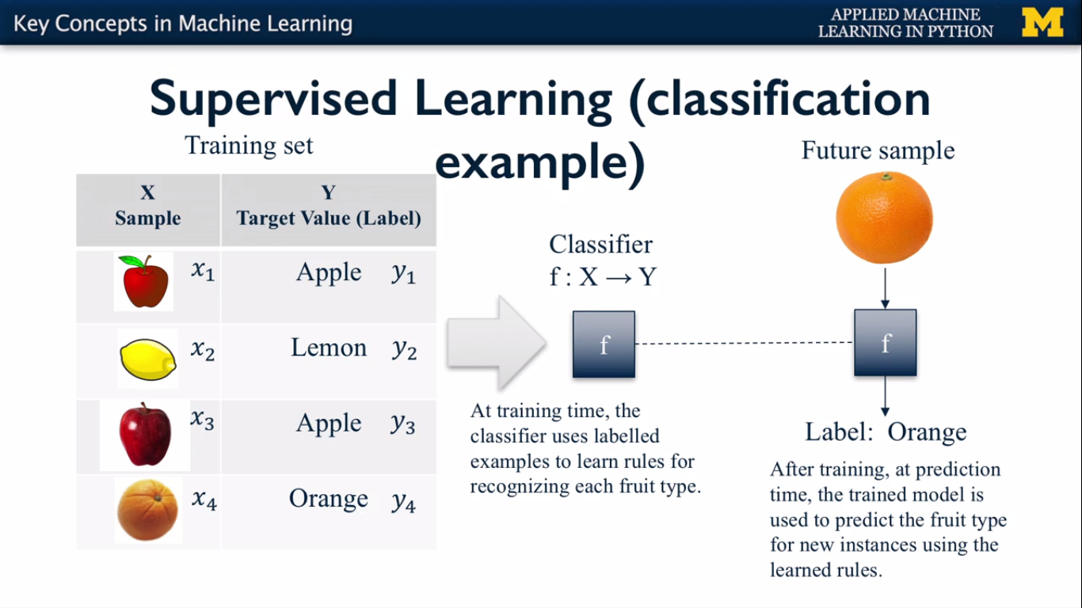

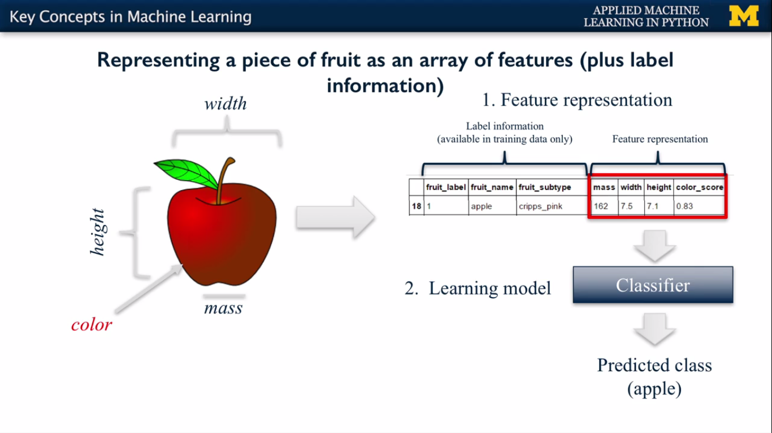

**Scipy Library:**

Provides a variety of useful scientific computing tools, with scikit-learn provides support for sparse matrices, a way to store large tables that consist mostly of 0(zero’s)

**Import scipy as sp**

**Numpy :**

Provides fundamental data structure used by scikit learn ,particularly multi dimensional arrays.

Data that is input to scikit -learn will be in the form of a NumPy array.

**Import numpy as np**

**Pandas:**

Provides key data structures like DataFrame

Also support for reading /writing data in different formats

**Import pandas as pd**

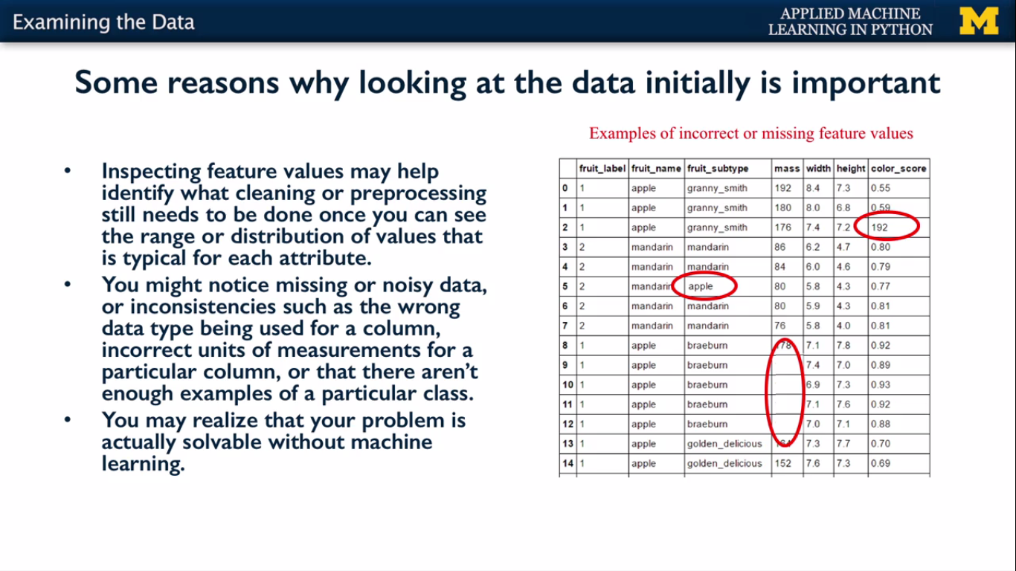

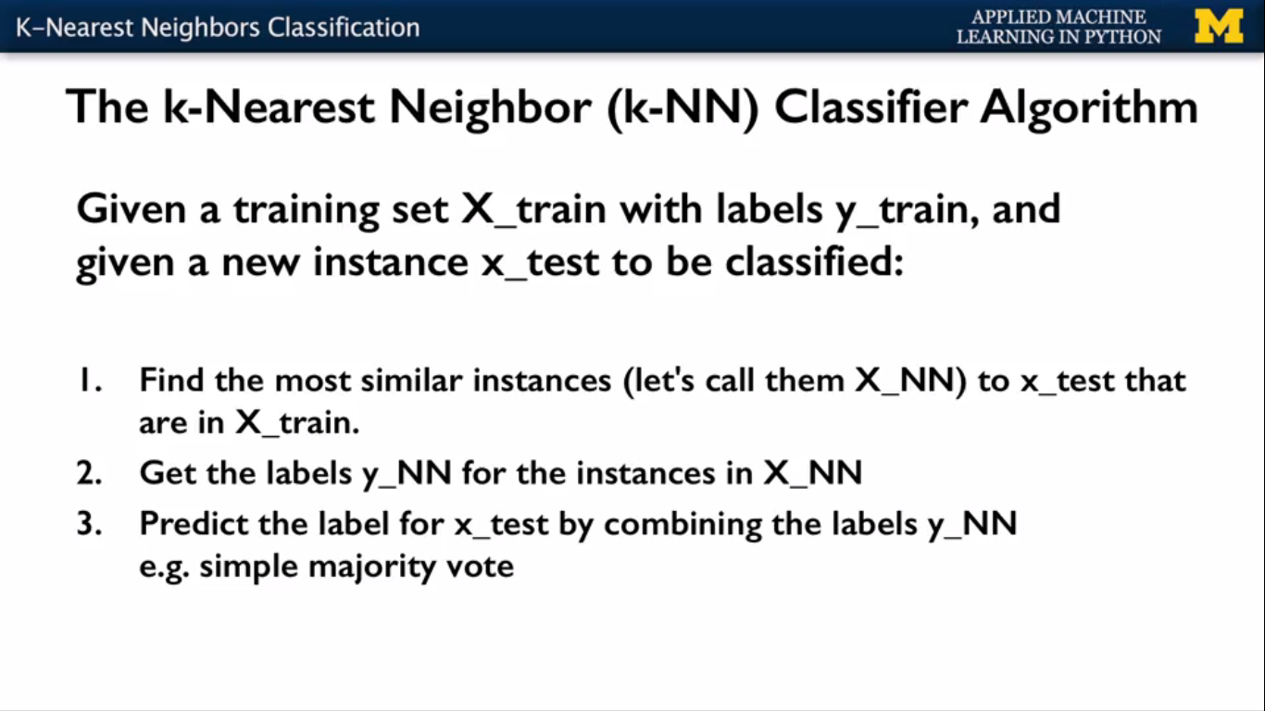

As a simple example to get started, we're going to use **fruit data set** to train a classifier that will automatically identify any future pieces of fruit that might come our way.

Based on the features available to the classifier such as the object's color,size and mass.

we'll use a popular and easy to understand type of machine learning algorithm known as k-nearest neighbors or k-NN.

The K-Nearest Neighbors algorithm can be used for classification and regression.

Though, here we'll focus for the time being on using it for classification.

k-NN classifiers are an example of what's **called instance based or memory based supervised learning**.

What this means is that instance based learning methods work by memorizing the labeled examples that they see in the training set.

And then they use those memorized examples to classify new objects later.

The k in k-NN refers to the number of nearest neighbors the classifier will

retrieve and use in order to make its prediction.

In particular, the k-NN algorithm has three steps that can be specified.

First of all, when given a new previously unseen instance of something to classify,

a k-NN classifier will look into its set of memorized training examples to find

the k examples that have closest features.

Second, the classifier will look up the class labels for those k-Nearest Neighbor examples.

And then once it's done that, it will combine the labels of those

examples to make a prediction for the label of the new object.

**#c3 ML**

**#w1 6_v start here**

**K-Nearest Neighbor (k-NN) Classifier Algorithm**

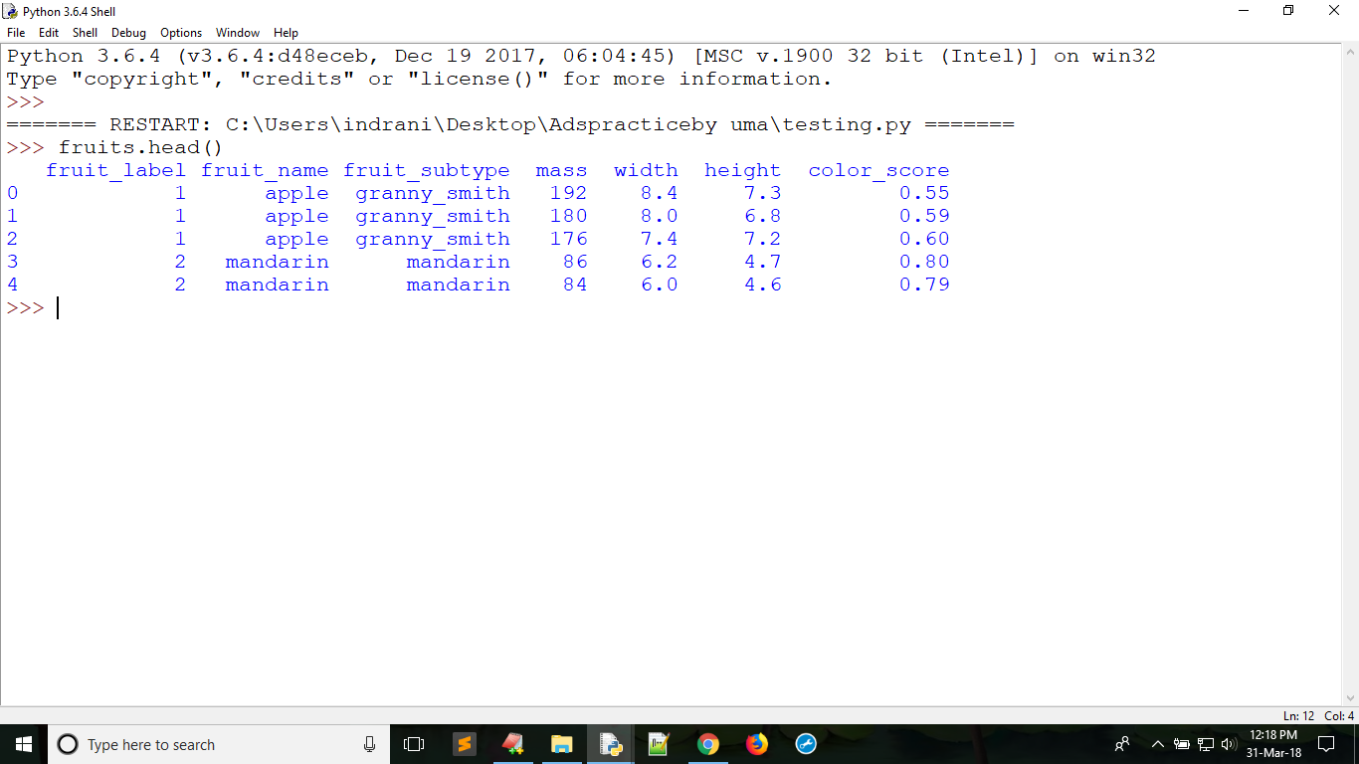figure: fruit_data

#import required modules and load data file

import numpy as np

import matplotlib.pyplot as plt

import pandas as pd

# to split data into training set and testing we import train_test_split from sklearn

from sklearn.model_selection import train_test_split

fruits=pd.read_table('fruit_data_with_colors.txt')

# to identify the name according to label uniquely

lookup_fruit_name=dict(zip(fruits.fruit_label.unique(),fruits.fruit_name.unique()))

X=fruits[['mass','width','height']]

y=fruits['fruit_label']

**# tarin_test_split(training features ,training label,random_state=integer) here random_state=0 to get same output when run multiple times**

**#So the default split in scikit learn is typically 75, 25.**

X_train,X_test,y_train,y_test=train_test_split(X,y,random_state=0)

#to create Knn classifier obj

from sklearn.neighbors import KNeighborsClassifier as KNcls

#knn obj requires n_neighbors to compare with 5 neighbors(we give integer as odd number)

knn=KNcls(n_neighbors=5)

**#to train machine we use fit function from the knn object and fit requires training features/inputs and ouput labels for that features**

knn.fit(X_train,y_train)

#to test knn classifier accuracy for training and test data we use **score** function from knn obje

print(knn.score(X_test,y_test))

**#to predict new value we use predict function and pass list of features as a list**

fruit_prediction=knn.predict([ [20,4.3,5.5],[21,4.5,5.6] ])

**#Here predict function returns label so we identify fruit according to label we get**

op1,op2=lookup_fruit_name[fruit_prediction[0]],lookup_fruit_name[fruit_prediction[1]]

print(op1,op2)

#plot the decision boundaries of the k-NN classifier

#from adspy_shared_utilities import plot_fruit_knn

#plot_fruit_knn(X_train,y_train,5,'uniform')

#How sensitive is k-NN classification accuracy to the choice of k parameter

k_range=range(1,20)

scores=[]

for k in k_range:

knn=KNcls(n_neighbors=k)

knn.fit(X_train,y_train)

scores.append(knn.score(X_test,y_test))

plt.figure()

plt.xlabel('k')

plt.ylabel('accuracy')

plt.scatter(k_range,scores)

plt.xticks([0,5,10,15,20])

plt.show()

**#c3 w1 6_v end here**

**K-nearest neighbors doesn't make a lot of assumptions about the structure of the data and gives potentially accurate, but sometimes unstable predictions.**

**And by unstable I mean that it can be sensitive to small changes in the training data**

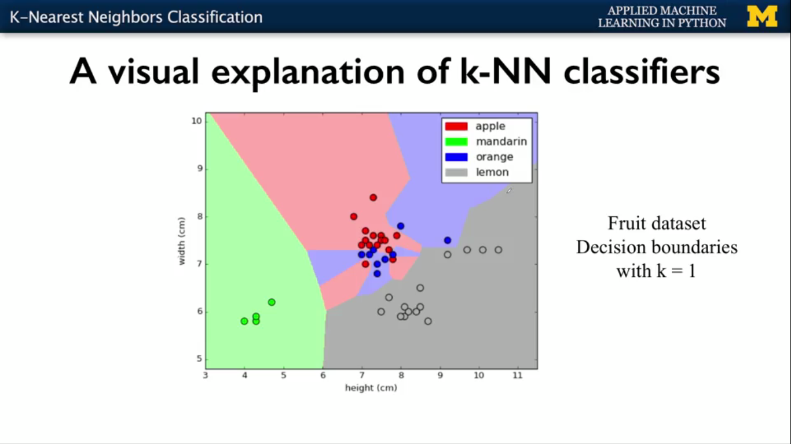

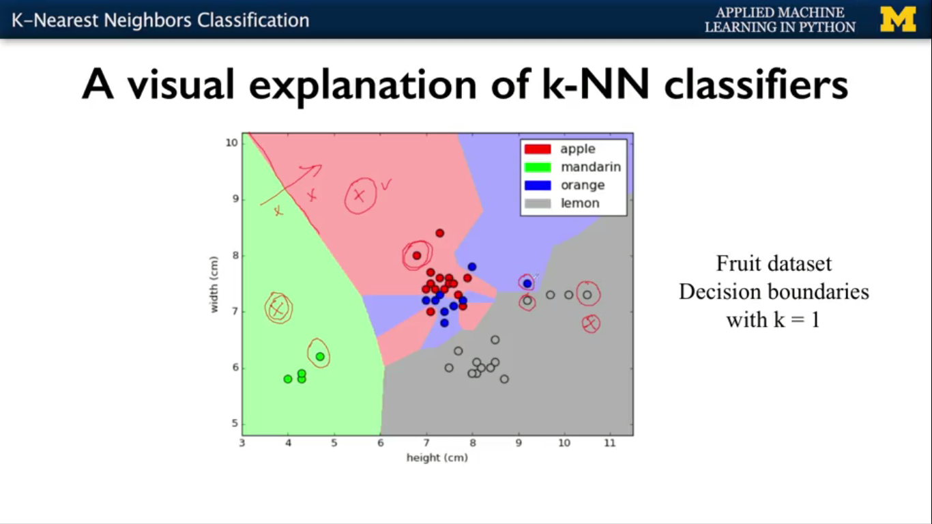

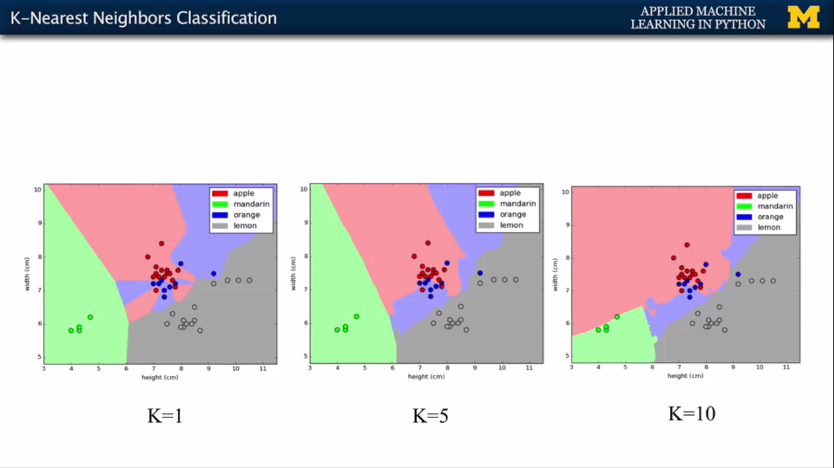

a basic sample of supervised machine learning using a k-nearest neighbor classifier,

classifying different types of fruit based on their various physical properties.

Machine learning algorithms of this type are called supervised learning

algorithms because they use labeled examples in the training set to learn how to predict the labels for new, previously unseen examples.

The supervised aspect refers to the need for each training example to have a label in order for

the algorithm to learn how to make accurate predictions on future examples.

This is in contrast to unsupervised machine learning where we don't have labels for the training data examples, and we'll cover unsupervised learning in a later part of this course.

This week, we'll explore supervised learning in a bit more depth,

Instead, we'll focus on some higher-level goals.

How to apply a number of specific supervised machine learning algorithms and

how to interpret their results for important tasks.

This will include understanding how supervised learning algorithms estimate

their parameters from data, how the train model makes predictions for new instances.

The strengths, weaknesses and best scenarios to apply a particular method and

how to use the method with its parameter settings in Python programs using scikit-learn.

Across all of these algorithms we'll discuss some general principles

that are critical to machine learning, like the issue of overfitting and how overfitting relates

to a models complexity.

And which parameters typically can be used to control model complexity in order to obtain good

performance on previously unseen data.

In this module we won't have time to cover all the different parameters for the various supervised learning methods.

So we'll focus on a small number of the most important parameters.

Variable capital X refer to the feature columns that will going into as the inputs for the predictor

And we use lower case y in Python for the variable name to hold

he target values associated with each instance.

**Example**

**From above task**

**We give mass,width,height as a feature input to the predictor and based on the features predictor identifies and return the corresponded and predicted label and we convert label to fruit_name**

Supervised learning can be divided into two different types of tasks, classification and regression.

Both classification and regression take a set of training instances and learn a mapping to a target value.

For classification, the target value is a discrete class value.

Again 3 types classification

A:**Binary classification**

B:**Multi-class classification**

C:**Multi label classification(**discuss later**)**

A **binary classification** problem has a two types of target values.

0 representing the negative class or 1 representing the positive class.

trying to detect a fraudulent credit card transaction. The transaction is either valid

or invalid.

The second type of classification problem is known as **multi-class classification**,

where the target value is more than just a yes or a no, or 1 or 0, it could be one of a set of discrete values.

For example, the labeling fruit example that we saw from the first part of the course is an example of multi-class classification because the object that we're trying to predict the label for can only have one of the possible label types. Something couldn't be for example both an apple and an orange.

**#C3 w2 v1**

for regression, the target we're trying to predict is a continuous value. For example, a model that predicts the market price of a house, given how many rooms it has, where its located, the size of the land that it sits on and so forth, would be a regression problem.

Because the market price is continuous, otherwise known as a real value variable. You can tell what type of supervisor learning method you should apply to a given problem by thinking about the meaning of the target value. Does the target value represent something that's one of a set of mutually exclusive class values as in the case of assigning a label to a piece of fruit?

Or whether or not a transaction is fraudulent? If so, it's a classification problem.

On the other hand, if the target is a real value quantity like cost, or income, or height then it can be treated as a regression problem.

Finally, we'll see that many supervised learning methods come in both flavors of classification and regression.

For example, support vector classifiers which we'll cover shortly also has a regression version called not surprisingly support vector regression.

In this course, we'll cover both classification and regression methods.

To start with, we'll look at two simple but powerful prediction algorithms.

**K-nearest neighbours**, which we saw in week one and

**linear model fitting using least-squares.**

**#c3 w2 3v**  
  
import matplotlib as mpl  
cmap_bold=mpl.colors.ListedColormap(['#FFF00','#00FF00','#0000FF','#00000'])  
fruits=pd.read_table('fruit_data_with_colors.txt')  
feature_names_fruits=['height','width','mass','color_score']  
X_fruits=fruits[feature_names_fruits]  
y_fruits=fruits['fruit_label']  
target_names_fruits=['apple','mandarin','orange','lemon']  
X_fruits_2d=fruits[['height','width']]  
y_fruits_2d=fruits['fruit_label']

**# sample regression problem start**

from sklearn.datasets import make_regression

plt.figure()

plt.title('sample regression problem with one input variable')

X_R1,y_R1=make_regression(n_samples=100,n_features=1,n_informative=1,bias=150.0,noise=30,random_state=0)

#start comment here

n_samples : int, optional (default=100)

The number of samples.

n_features : int, optional (default=100)

The number of features.

n_informative : int, optional (default=10)

The number of informative features, i.e., the number of features used to build the linear model used to generate the output.

n_targets : int, optional (default=1)

The number of regression targets, i.e., the dimension of the y output vector associated with a sample. By default, the output is a scalar.

bias : float, optional (default=0.0)

The bias term in the underlying linear model.

effective_rank : int or None, optional (default=None)

if not None:

The approximate number of singular vectors required to explain most of the input data by linear combinations. Using this kind of singular spectrum in the input allows the generator to reproduce the correlations often observed in practice.

if None:

The input set is well conditioned, centered and gaussian with unit variance.

tail_strength : float between 0.0 and 1.0, optional (default=0.5)

The relative importance of the fat noisy tail of the singular values profile if effective_rank is not None.

noise : float, optional (default=0.0)

The standard deviation of the gaussian noise applied to the output.

shuffle : boolean, optional (default=True)

Shuffle the samples and the features.

coef : boolean, optional (default=False)

If True, the coefficients of the underlying linear model are returned.

random_state : int, RandomState instance or None, optional (default=None)

If int, random_state is the seed used by the random number generator; If RandomState instance, random_state is the random number generator; If None, the random number generator is the RandomState instance used by np.random.

Returns:

X : array of shape [n_samples, n_features]

The input samples.

y : array of shape [n_samples] or [n_samples, n_targets]

The output values.

coef : array of shape [n_features] or [n_features, n_targets], optional

The coefficient of the underlying linear model. It is returned only if coef is True.

#comment end here

print(X_R1,y_R1,sep='\n\n',end='\n\n')

plt.scatter(X_R1,y_R1,marker='o',s=50)

plt.show()

**#sample regression problem end**

**#complex reg start**

from sklearn.datasets import make_friedman1

plt.figure()

plt.title('Complex Regression problem with one input')

X_F1,y_F1=make_friedman1(n_samples=100,n_features=7,random_state=0)

print(type(X_F1),X_F1,y_F1,sep='\n\n',end='\n\n')

plt.scatter(X_F1[:,2],y_F1,marker='o',s=50)

plt.show()

**#complex reg end**

**#c3 w2 v5**

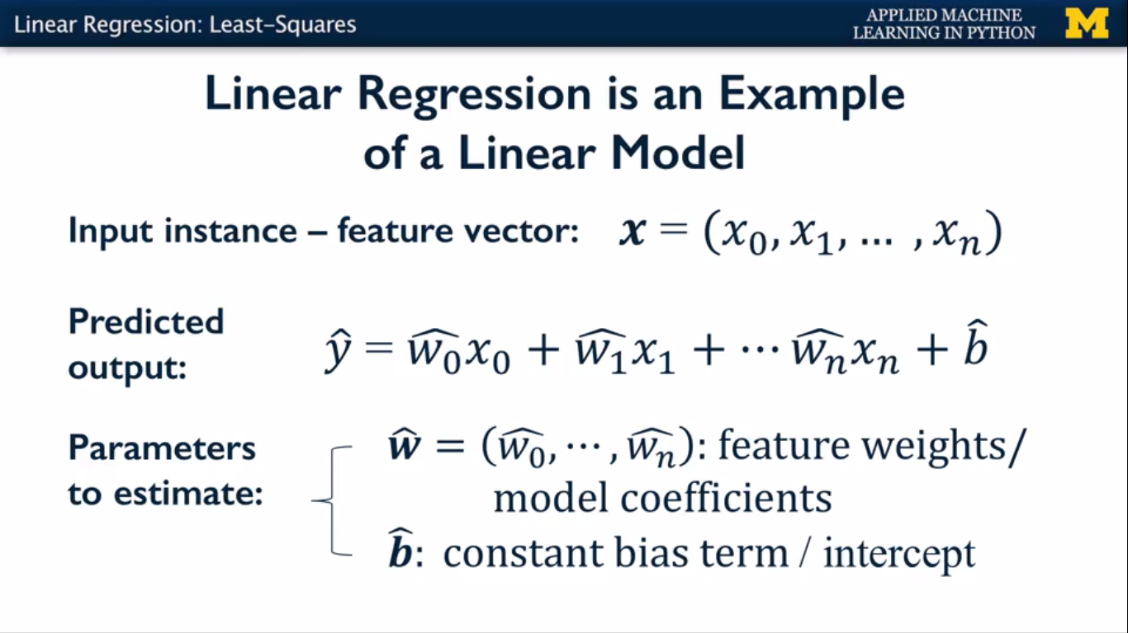

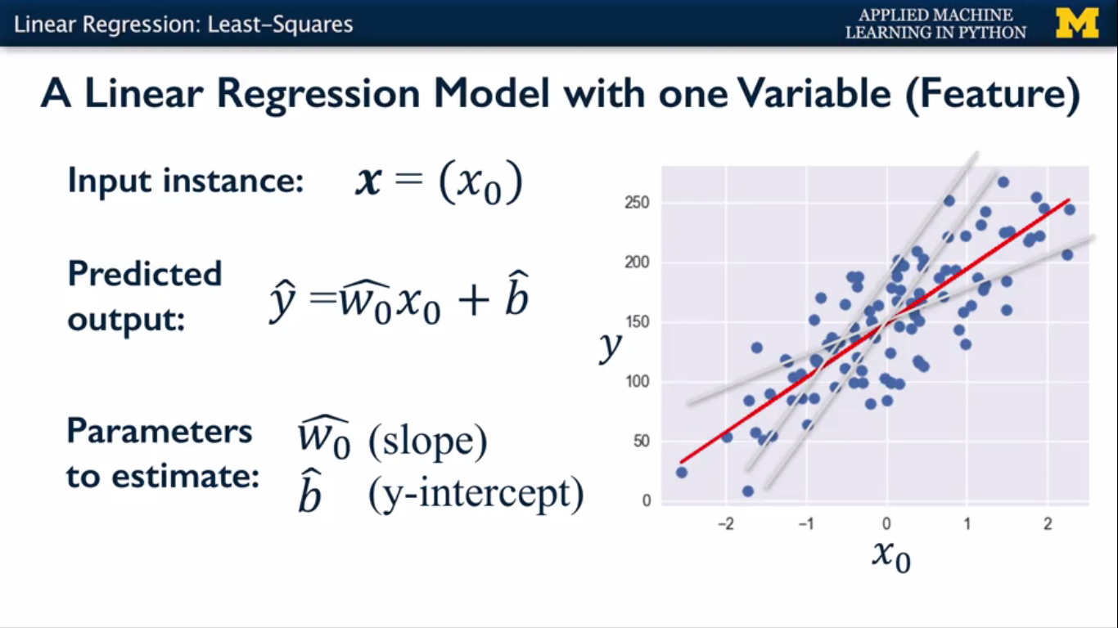

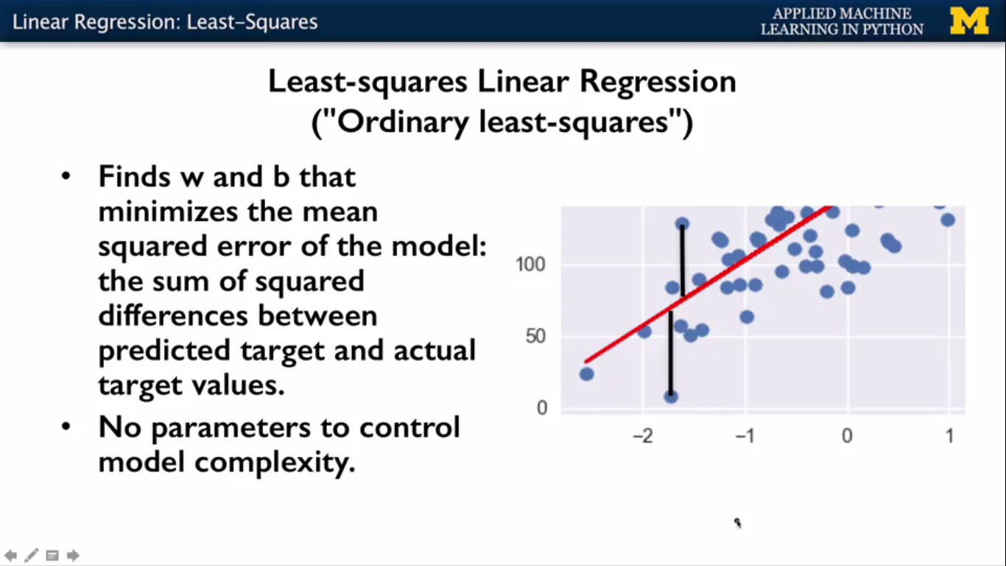

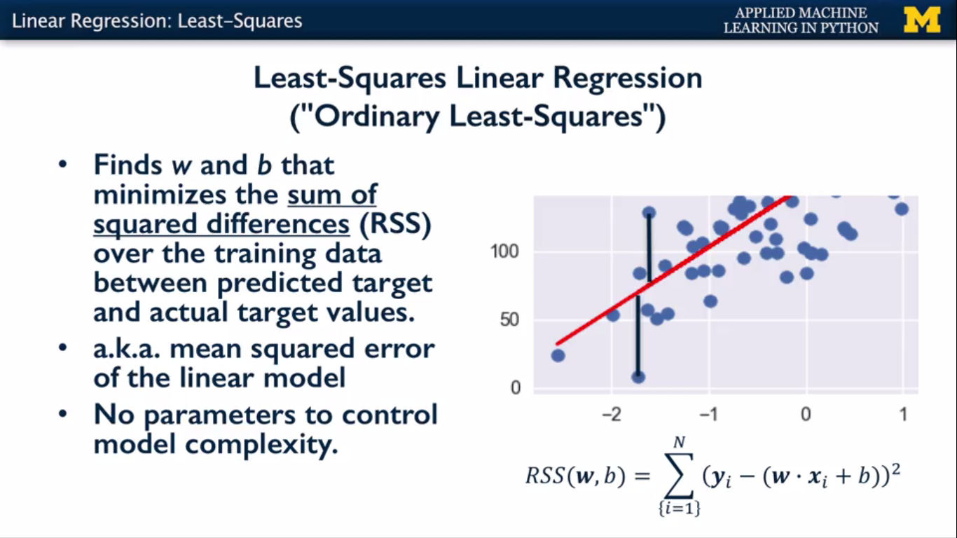

**Fig 2**

**#least square Linear Regression in sklearn start**

from sklearn.model_selection import train_test_split

from sklearn.linear_model import LinearRegression

from sklearn.datasets import make_regression

X_R1,y_R1=make_regression(n_samples=10,n_features=1,n_informative=1,bias=150.0,noise=30,random_state=0)

X_train,X_test,y_train,y_test=train_test_split(X_R1,y_R1,random_state=0)

linreg=LinearRegression().fit(X_train,y_train)

print('linear model intercept (b):{}'.format(linreg.intercept_))

print('linear model coeff (w) :{}'.format(linreg.coef_))

#y=mx+c

#m=coef c=intercept

print('R-squared score (training): {:.3f}'.format(linreg.score(X_train,y_train)))

print('R-squared score (test): {:,.3f}'.format(linreg.score(X_test,y_test)))

plt.figure(figsize=(5,4))

#print(X_R1,y_R1,linreg.coef_,sep='\n\n-->\n')

plt.scatter(X_R1,y_R1,marker='o',s=50,alpha=0.8)

plt.plot(X_R1,linreg.coef_*X_R1+linreg.intercept_,'r-')

plt.title('Least-squares linear regression')

plt.xlabel('Feature value(x)')

plt.ylabel('Target value (y)')

plt.show()

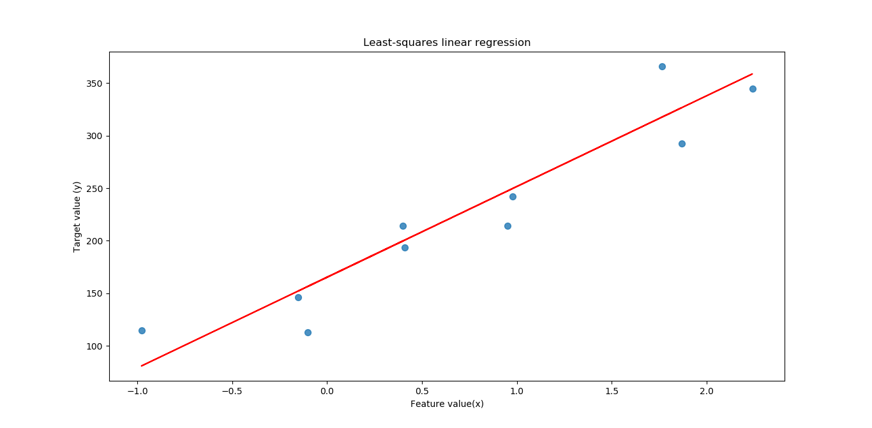

**#least square Linear Regression in sklearn end**

**#c3 w2 v6 3:16**

**#Ridge Regression start**

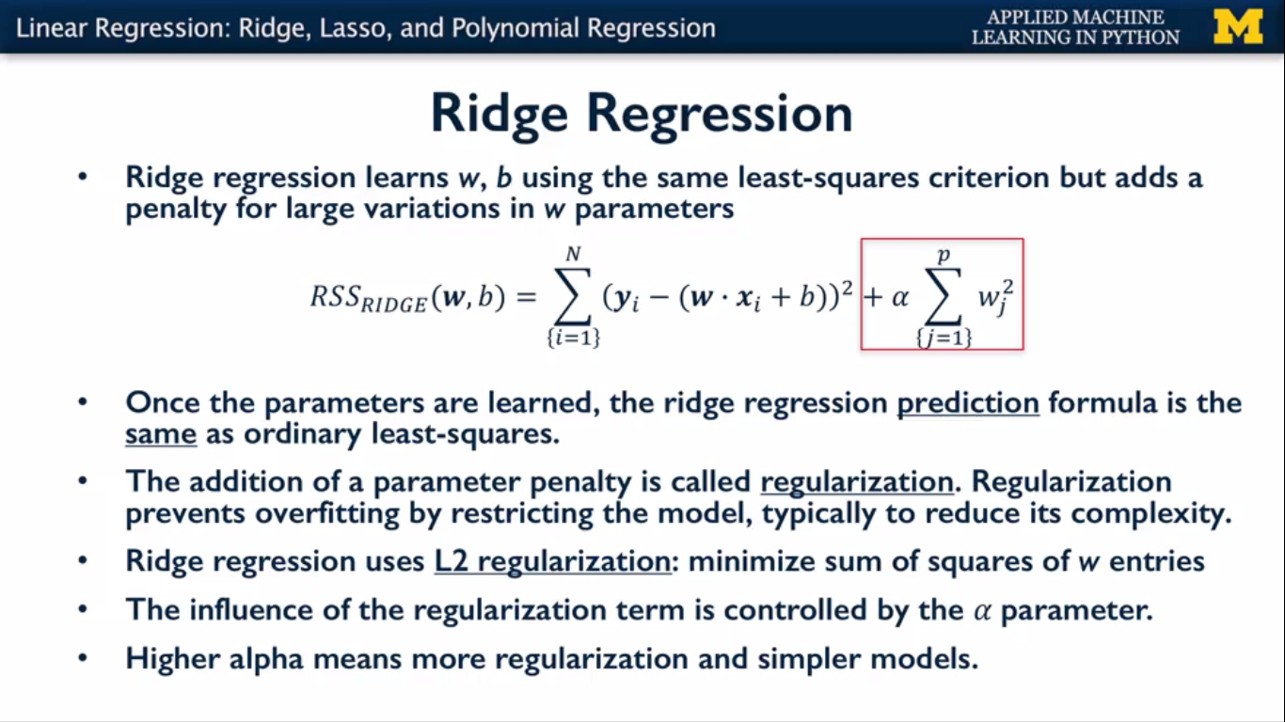

Ridge regression uses the same least-squares criterion, but with one difference.

During the training phase,it adds a penalty for feature weights,

The Wi values that are too large as shown in the equation here.You'll see that large weights means mathematically that the sum of their squared values is large.

The ridge regression reduce the wi values of the feature and by adding penalty factor

This addition of a penalty term to a learning algorithm's objective function is called Regularisation.  
Regularisation is an extremely important concept in machine learning. It's a way to prevent overfitting, and thus, improve the likely generalization performance of a model,  
by restricting the models possible parameter settings.  
The amount of regularisation to apply is controlled by the **alpha** parameter.

**Larger alpha** means **more regularization** and The default setting for alpha is 1.0.

Notice that setting alpha to zero corresponds to the special case of ordinary least-squares linear regression that we saw earlier,

from sklearn.model_selection import train_test_split

crime = pd.read_table('CommViolPredUnnormalizedData.txt', sep=',', na_values='?')

#crime2=crime.copy()

# remove features with poor coverage or lower relevance, and keep ViolentCrimesPerPop target #column

columns_to_keep = [5, 6] + list(range(11,26)) + list(range(32, 103)) + [145]

crime = crime.ix[:,columns_to_keep].dropna()

X_crime = crime.ix[:,range(0,88)]

y_crime = crime['ViolentCrimesPerPop']

from sklearn.linear_model import Ridge

X_train,X_test,y_train,y_test=train_test_split(X_crime,y_crime,random_state=0)

linridge=Ridge(alpha=20.0).fit(X_train,y_train)

print('ridge regression linear model intercept: {}'.format(linridge.intercept_))

print('ridge regression linear model coeff:\n{}'.format(linridge.coef_))

print('R-squared score (training): {:.3f}'.format(linridge.score(X_train,y_train)))

print('R-squared score (test): {:.3f}'.format(linridge.score(X_test,y_test)))

print('Number of Non zero features: {}'.format(np.sum(linridge.coef_!=0)))

**#Ridge Regression end**

**# to observe difference b/w linear regression and ridge regression**

from sklearn.linear_model import LinearRegression

linreg=LinearRegression().fit(X_train,y_train)

#And view the coef_ of linear reg and ridge regression

**#c3 w2 v6 9:0**

**#Ridge Regression with feature normalization start**

The type of feature preprocessing and normalization that's needed can also depend on the data.

For now, we're going to apply a widely used form of **future normalization called MinMax Scaling**, that will transform all the input variables, so they're all on the **same scale between zero and one**.

To do this, we compute the minimum and maximum values for each feature on the training data,

and then apply the minmax transformation for each feature as shown here.

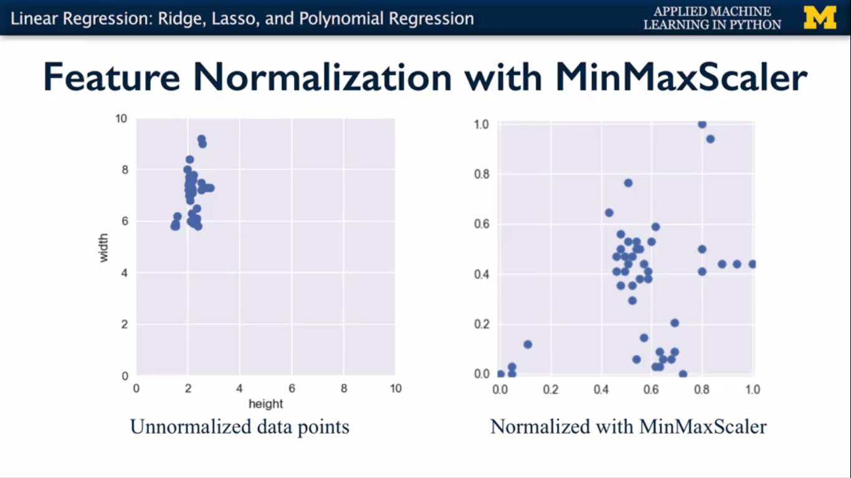

from sklearn.datasets import make_regression

X_R1,y_R1=make_regression(n_samples=100,n_features=1,n_informative=1,bias=150.0,noise=30,random_state=0)

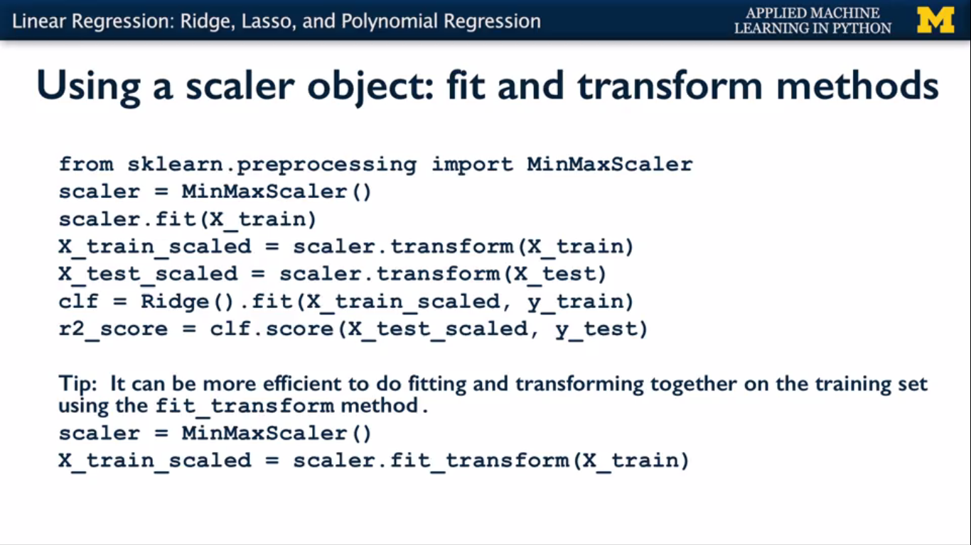

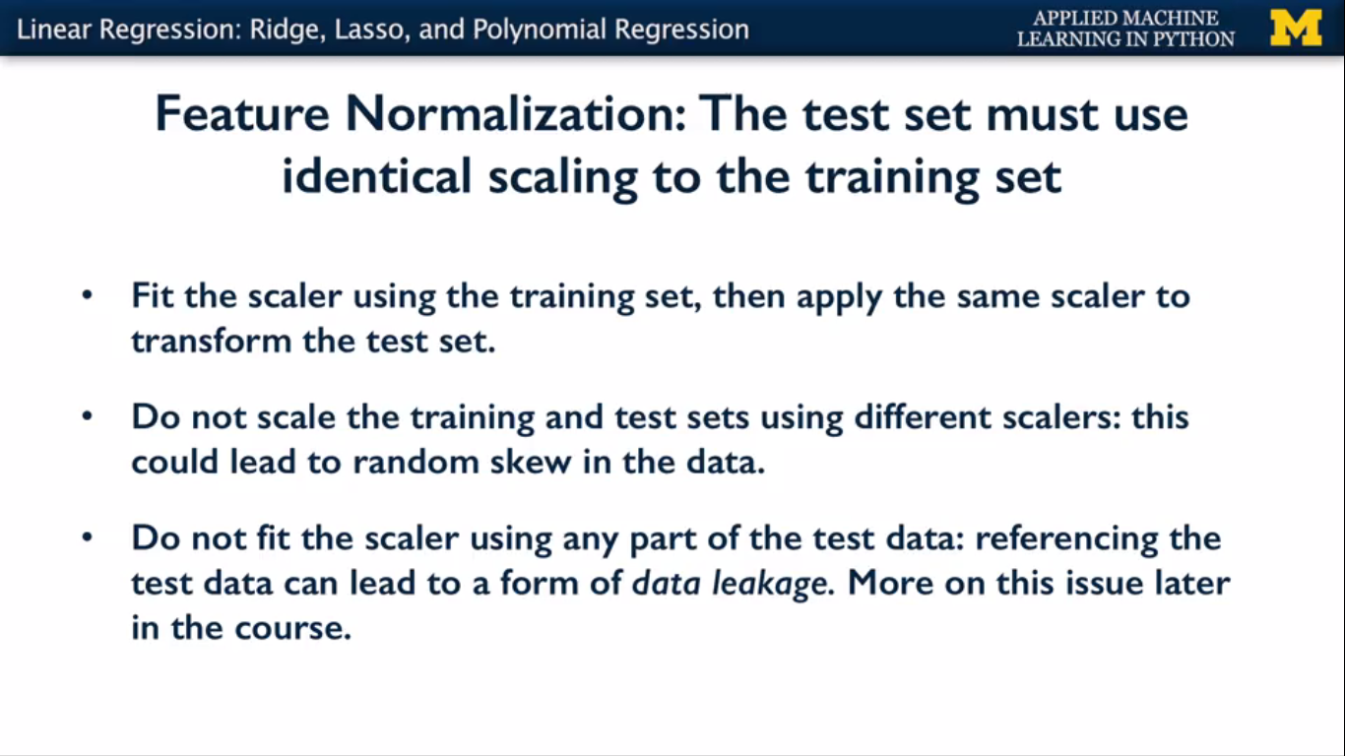

from sklearn.preprocessing import MinMaxScaler

scaler=MinMaxScaler()

#from sklearn.linear_model import Ridge

#from sklearn.model_selection import train_test_split

#X_train,X_test,y_train,y_test=train_test_split(X_crime,y_crime,random_state=0)

X_train_scaled=scaler.fit_transform(X_train)

X_test_scaled=scaler.transform(X_test)

linridge_scaled=Ridge(alpha=20.0).fit(X_train_scaled,y_train)

print('ridge regression linear model intercept: {}'.format(linridge_scaled.intercept_))

print('ridge regression linear model coeff:\n{}'.format(linridge_scaled.coef_))

print('R-squared score (training): {:.3f}'.format(linridge_scaled.score(X_train_scaled,y_train)))

print('R-squared score (test): {:.3f}'.format(linridge_scaled.score(X_test_scaled,y_test)))

print('Number of Non zero features: {}'.format(np.sum(linridge_scaled.coef_!=0)))

**#Ridge Regression with feature normalization end**

**#c3 w2 v6 10:00,12:55**

**#Lasso regression start**

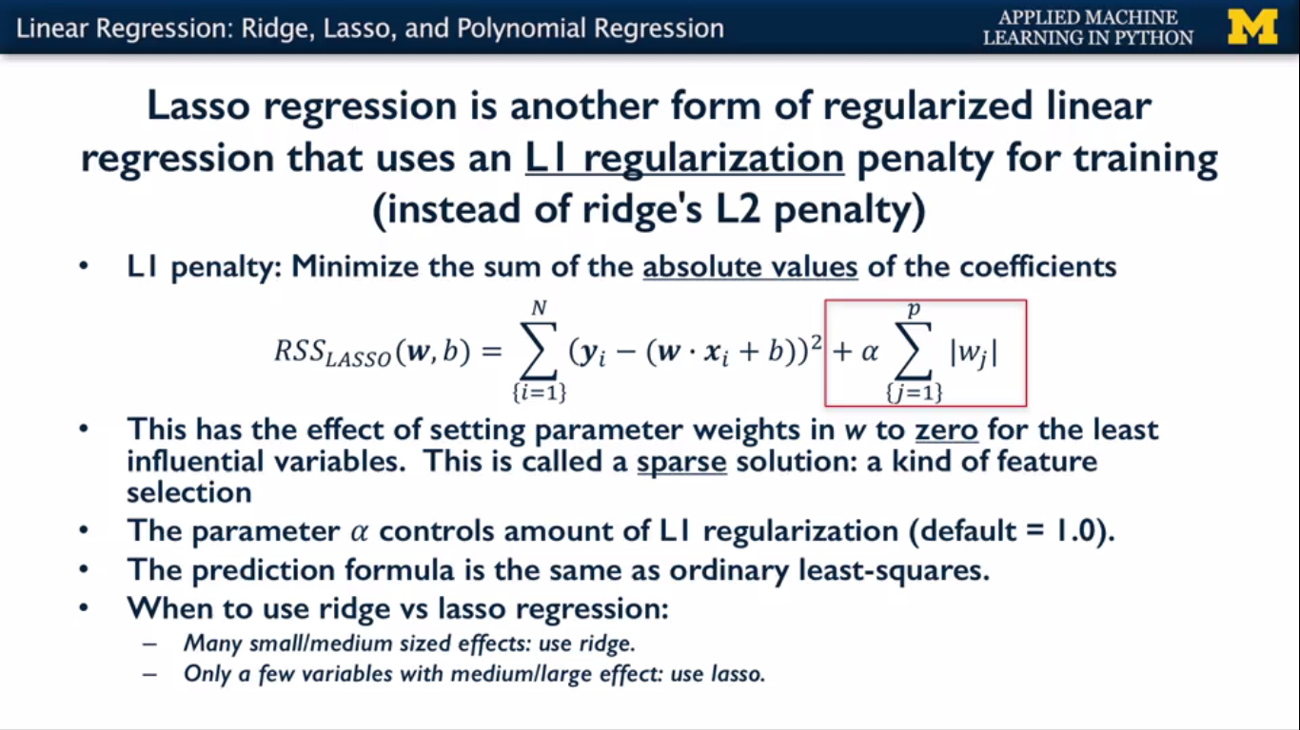

Like ridge regression, lasso regression adds a regularisation penalty term to the ordinary least-squares objective, that causes the model W-coefficients to shrink towards zero.

Lasso regression uses a slightly different regularisation term called an L1 penalty,

instead of ridge regression L2 penalty.

The L1 penalty looks kind of similar to the L2 penalty,in that it computes a sum over the coefficients but it's some of the absolute values of the W-coefficients instead of a sum of squares.

With lasso regression, a subset of the coefficients are forced to be precisely zero.

Which is a kind of automatic feature selection, since with the weight of zero the features are

essentially ignored completely in the model. This sparse solution where only a subset of

the most important features are left with non-zero weights, also makes the model easier to interpret.

**In general, lasso regression is most helpful if you think there are only a few variables that have a medium or large effect on the output variable.**

**Otherwise if there are lots of variables that contribute small or medium effects,**

**ridge regression is typically the better choice.**

most of the features are set to have weights of exactly zero.(output of coefficient)

from sklearn.linear_model import Lasso

from sklearn.preprocessing import MinMaxScaler

scaler=MinMaxScaler()

from sklearn.model_selection import train_test_split

crime = pd.read_table('CommViolPredUnnormalizedData.txt', sep=',', na_values='?')

columns_to_keep = [5, 6] + list(range(11,26)) + list(range(32, 103)) + [145]

crime = crime.ix[:,columns_to_keep].dropna()

X_crime = crime.ix[:,range(0,88)]

y_crime = crime['ViolentCrimesPerPop']

X_train,X_test,y_train,y_test=train_test_split(X_crime,y_crime,random_state=0)

X_train_scaled=scaler.fit_transform(X_train)

X_test_scaled=scaler.transform(X_test)

linlasso=Lasso(alpha=2.0,max_iter=10000).fit(X_train_scaled,y_train)

#better to set max_iter value to more(at least 20000) for converge problem

print('lasso regression linear model intercept: {}'.format(linlasso.intercept_))

print('lasso regression linear model coeff:\n{}'.format (linlasso.coef_))

print('Non-zero features: {}'.format(np.sum(linlasso.coef_!=0)))

print('R-squared score (training): {:.3f}'.format(linlasso.score(X_train_scaled,y_train)))

print('R-squared score(test): {:.3f}\n'.format(linlasso.score(X_test_scaled,y_test)))

print('Features with non zero weight (sorted by absolute magnitude):')

for e in sorted(list(zip(list(X_crime),linlasso.coef_)),key=lambda e:-abs(e[1])):

if e[1]!=0:

print('\t{}, {:.3f}'.format(e[0],e[1]))

**#Lasso regression end**

**#c3 w2 v6 14:25**

**#lasso regression with regularization parameter :alpha start**

print('Lasso regression : effect of alpha regularization \n\parameter on number of features kept in final model\n')

for alpha in [0.5,1,2,3,5,10,20,50]:

linlasso=Lasso(alpha,max_iter=10000).fit(X_train_scaled,y_train)

r2_train=linlasso.score(X_train_scaled,y_train)

r2_test=linlasso.score(X_test_scaled,y_test)

print('Alpha={:.2f}\n\Features kept: {},r-squared training: {:.2f}, \r-squared test : {:.2f}\n'.format(alpha,np.sum(linlasso.coef_!=0),r2_train,r2_test))

**#lasso regression with regularization parameter :alpha end**

**#c3 w2 v6 17:53**

**#Polynomial Regression start**

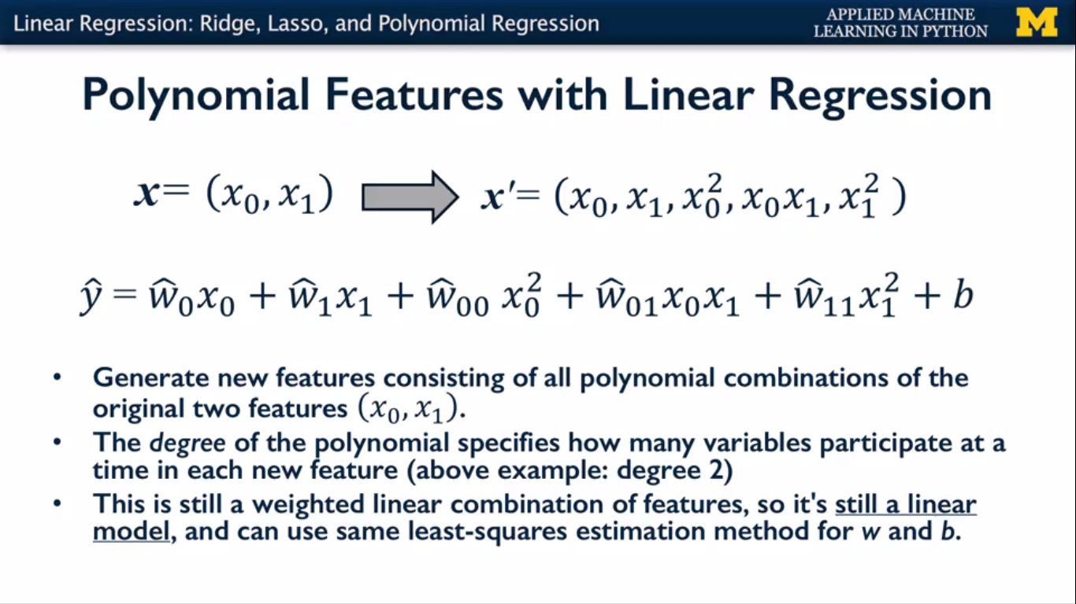

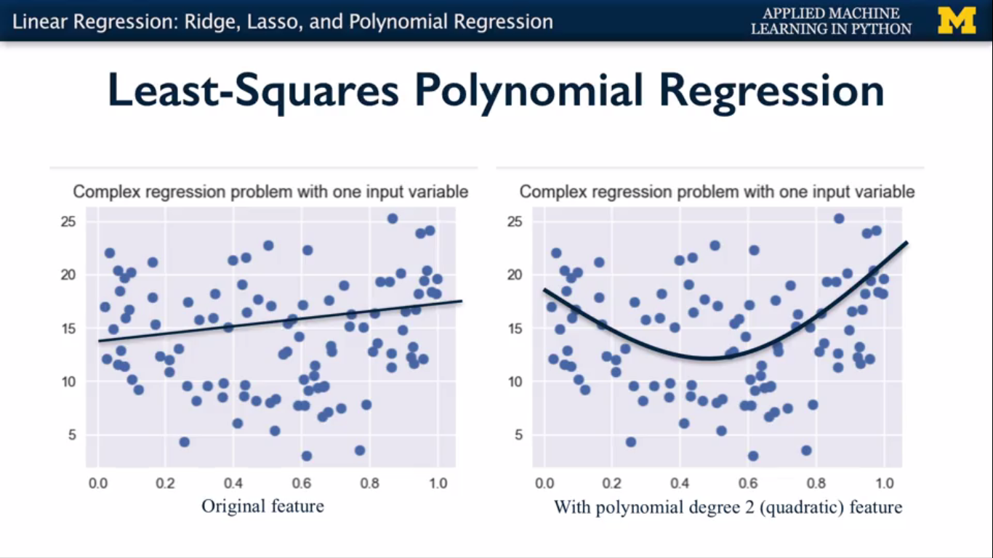

from sklearn.datasets import make_friedman1

X_F1,y_F1=make_friedman1(n_samples=100,n_features=7,random_state=0)

from sklearn.linear_model import LinearRegression

from sklearn.linear_model import Ridge

from sklearn.preprocessing import PolynomialFeatures

from sklearn.model_selection import train_test_split

X_train,X_test,y_train,y_test=train_test_split(X_F1,y_F1,random_state=0)

#first we apply linear regression

linreg=LinearRegression().fit(X_train,y_train)

print('linear model coeff (w): {}'.format(linreg.coef_))

print('linear model intercept (b): {:.3f}'.format(linreg.intercept_))

print('R-squared score (training): {:.3f}'.format(linreg.score(X_train,y_train)))

print('R-squared score(test): {:.3f}'.format(linreg.score(X_test,y_test)))

print('\nNow we transform the original input data to add\n\polynomial features up to degree 2 (quadratic)\n')

poly=PolynomialFeatures(degree=2)

X_F1_poly=poly.fit_transform(X_F1)

X_train,X_test,y_train,y_test=train_test_split(X_F1_poly,y_F1,random_state=0)

linreg=LinearRegression().fit(X_train,y_train)

print('(poly deg 2) linear model coeff (w):\n{}'.format(linreg.coef_))

print('(poly deg 2) linear model intercept (b): {:.3f}'.format(linreg.intercept_))

print('(poly deg 2) R-squared score (training): {:.3f}'.format(linreg.score(X_train,y_train)))

print('(poly deg 2) R-squared score(test): {:.3f}'.format(linreg.score(X_test,y_test)))

print('\n Addition of many polynomial features often leads to\n\overfitting, so we often use polynomial features in combination\n\with regression that has regularization penality,like ridge\n\regression.\n')

X_train,X_test,y_train,y_test=train_test_split(X_F1_poly,y_F1,random_state=0)

linreg=Ridge().fit(X_train,y_train)

print('(poly deg 2 + ridge) linear model coeff (w):\n{}'.format(linreg.coef_))

print('(poly deg 2 + ridge) linear model intercept (b): {:.3f}'.format(linreg.intercept_))

print('(poly deg 2 + ridge) R-squared score (training): {:.3f}'.format(linreg.score(X_train,y_train)))

print('(poly deg 2 + ridge) R-squared score(test): {:.3f}'.format(linreg.score(X_test,y_test))

**#Polynomial Regression end**

**#c3 w2 v7 12:29**

**#Logistic regression with real dataset start**

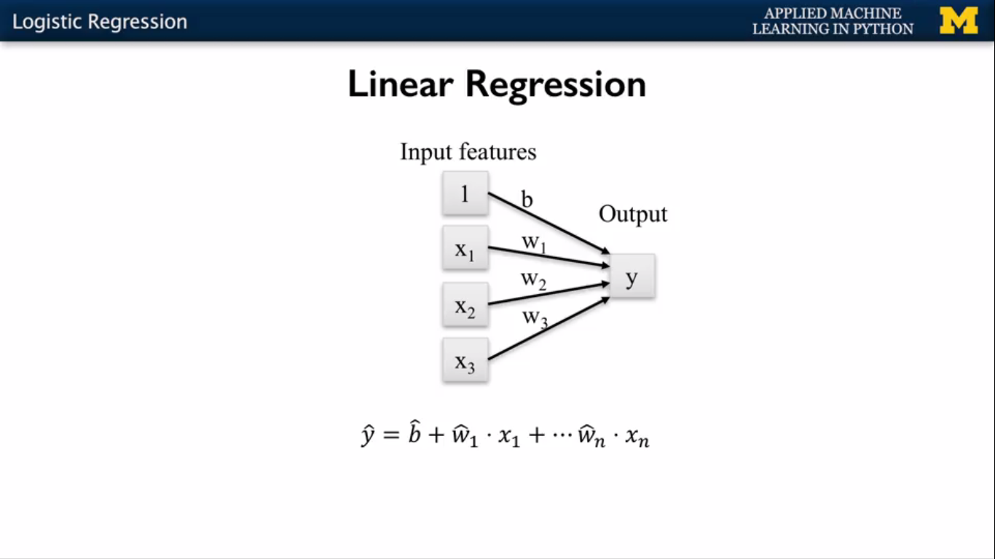

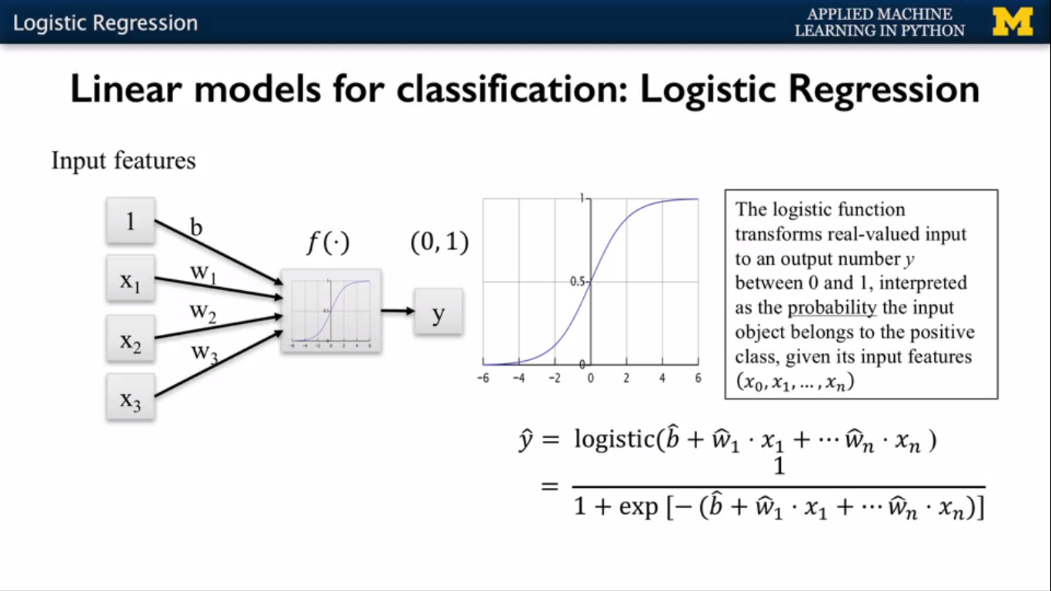

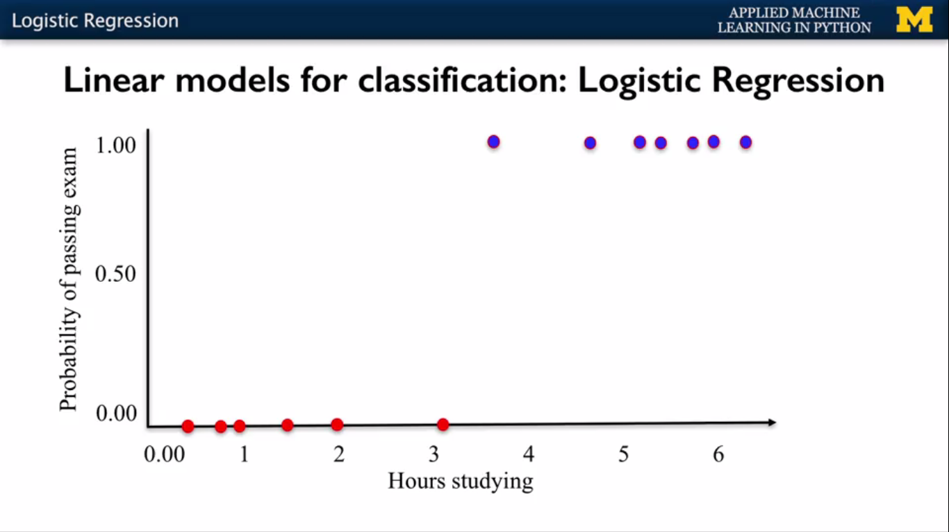

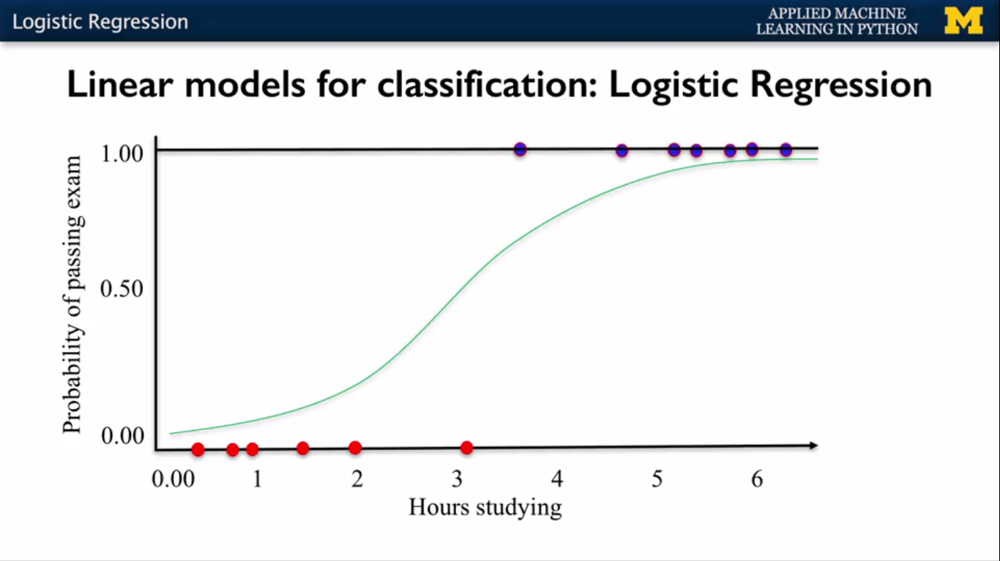

**#loading breast cancer data**

from sklearn.datasets import load_breast_cance

cancer = load_breast_cancer()

data = np.c_[cancer.data, cancer.target]

columns = np.append(cancer.feature_names, ["target"])

cancerdf=pd.DataFrame(data, columns=columns)

X_cancer = cancerdf[cancerdf.columns[:-1]]

y_cancer = cancerdf.target

from sklearn.model_selection import train_test_split

X_train,X_test,y_train,y_test=train_test_split(X_cancer,y_cancer,random_state=0)

from sklearn.linear_model import LogisticRegression

clf=LogisticRegression().fit(X_train,y_train)

print('Breast Cancer dataset')

print('Accuracy of Logistic regression classifier on training set: {:.2f}'.format(clf.score(X_train,y_train)))

print('Accuracy of Logistic regression classifier on test set: {:.2f}'.format(clf.score(X_test,y_test)))

**#Logistic regression with real dataset end**

**#c3 w2 v11 3:21**

**#cross validation start**

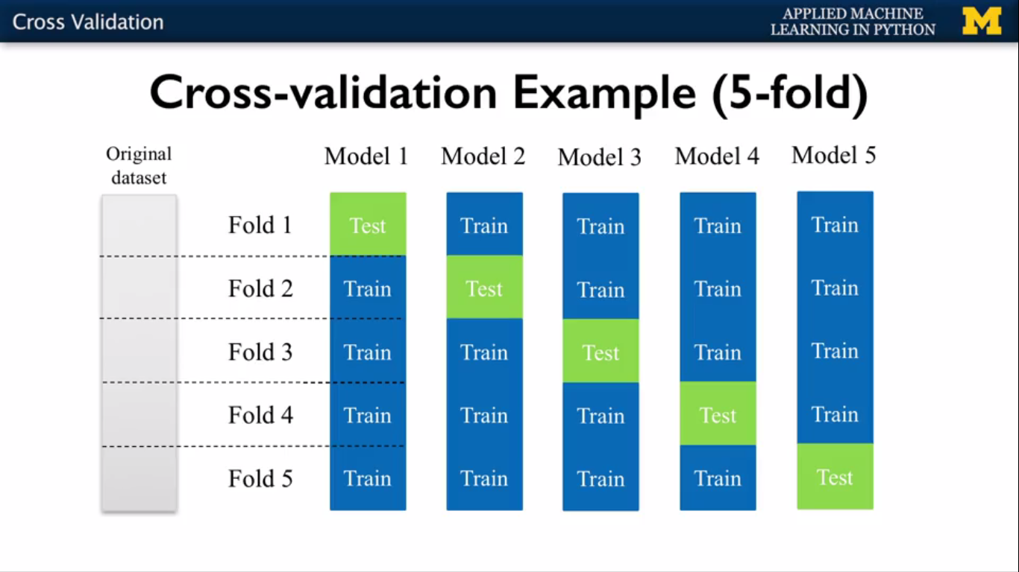

#Example based on k-NN classifier with fruit dataset(2 features)

from sklearn.model_selection import cross_val_score

from sklearn.neighbors import KNeighborsClassifier

fruits=pd.read_table('fruit_data_with_colors.txt')

X_fruits_2d=fruits[['height','width']]

y_fruits_2d=fruits['fruit_label']

clf=KNeighborsClassifier(n_neighbors=5)

X=X_fruits_2d.as_matrix()

y=y_fruits_2d.as_matrix()

cv_scores=cross_val_score(clf,X,y)#cv_scores default 3 fold ro set cv=10 as argument

#cv_scores=cross_val_score(clf,X,y,cv=4)

print('Cross-validation scores (3-fold): ',cv_scores)

print('Mean cross-validation score (3-fold): {:.3f}'.format(np.mean(cv_scores)))

**#cross validation end**

**#c3 w2 v12 9:27**

**#Decision Trees**

#using IRIS dataset

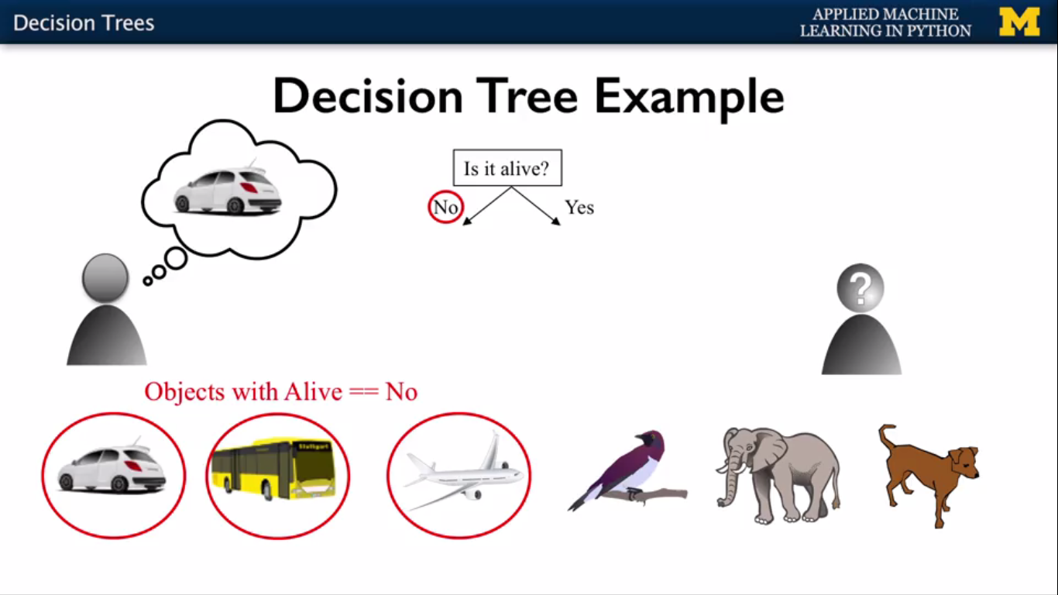

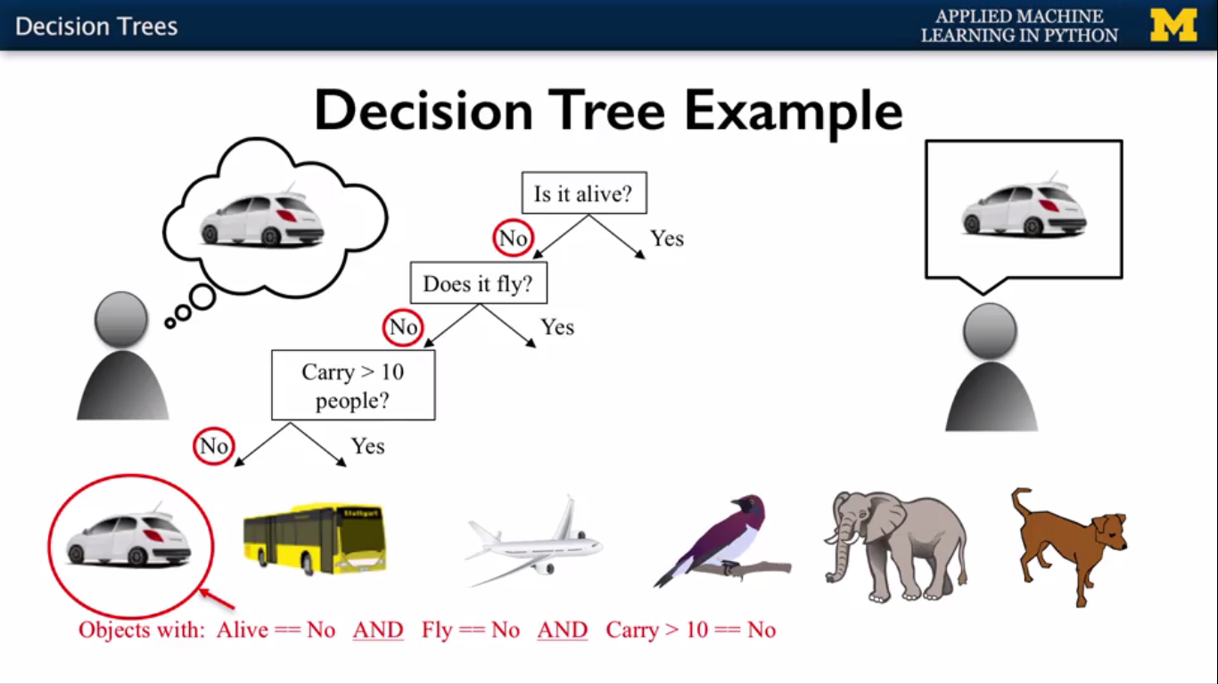

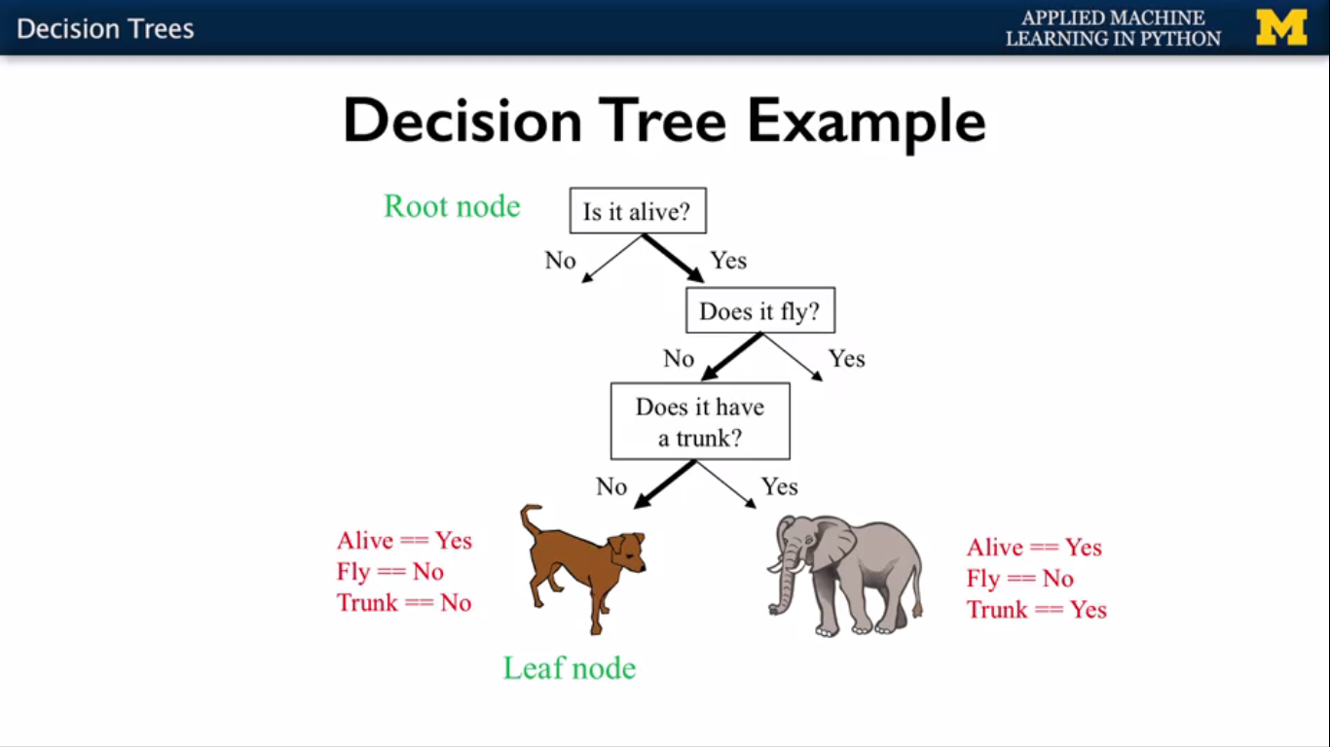

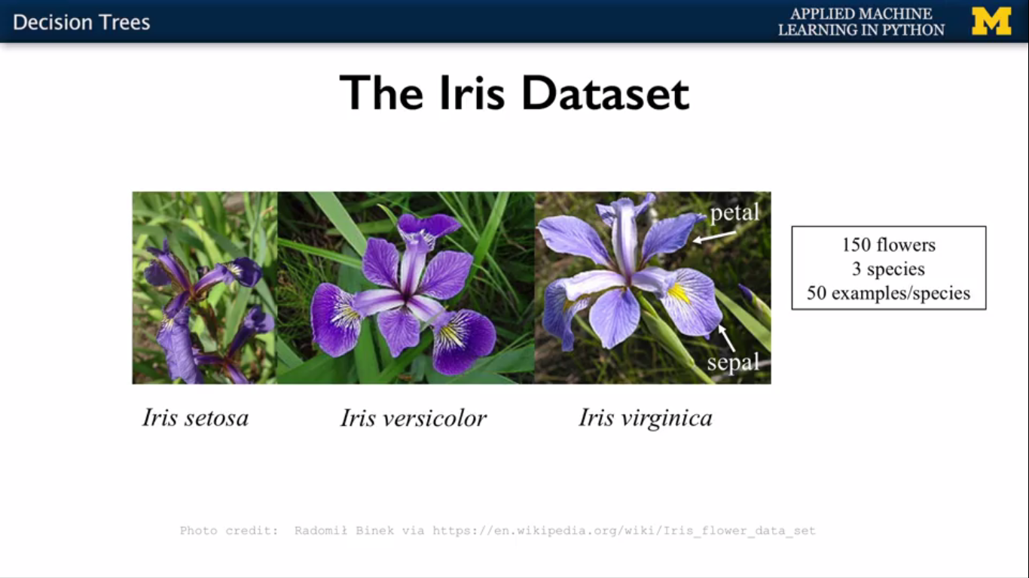

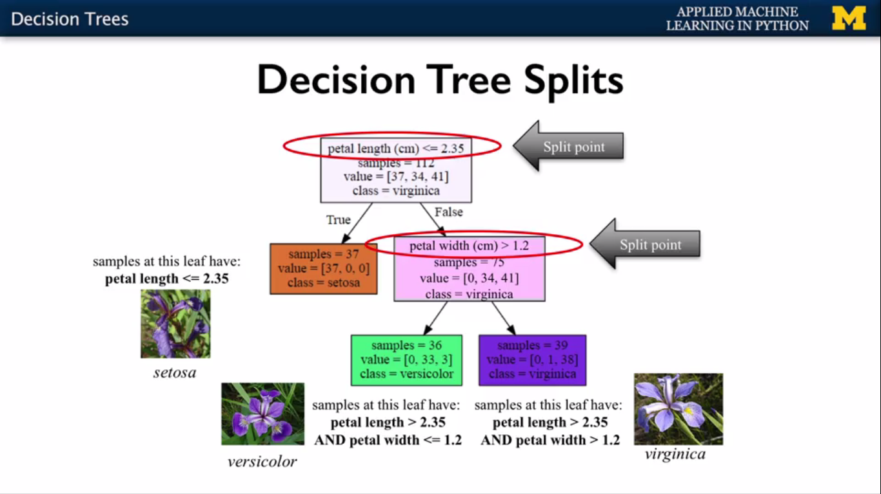



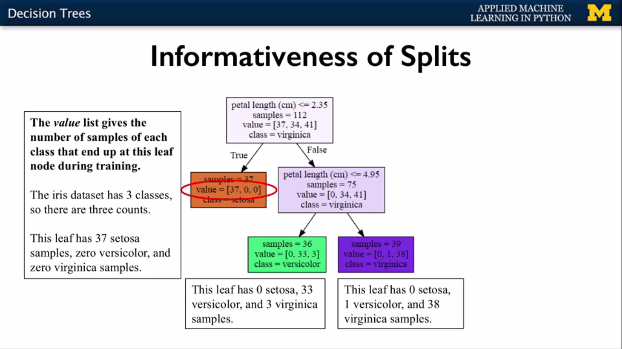

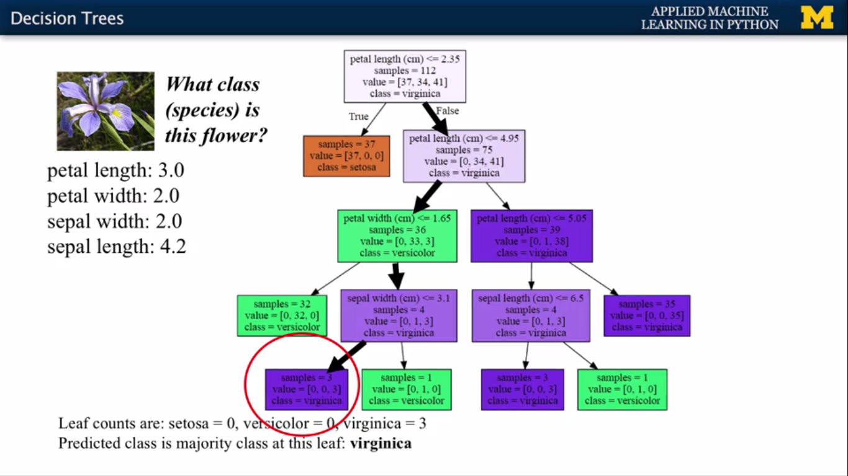

from sklearn.datasets import load_iris

from sklearn.tree import DecisionTreeClassifier

from sklearn.model_selection import train_test_split

iris=load_iris()

X_train,X_test,y_train,y_test=train_test_split(iris.data,iris.target,random_state=3)

clf=DecisionTreeClassifier().fit(X_train,y_train)

print('Accuracy of Decision tree classifier on train set: {:.2f}'.format(clf.score(X_train,y_train)))

print('Accuracy of Decision tree classifier on test set: {:.2f}'.format(clf.score(X_test,y_test)))

**# end**

**#c3 w2 v12 10:45**

**#setting max decision tree depth to avoid overfitting start**

#with IRIS dataset

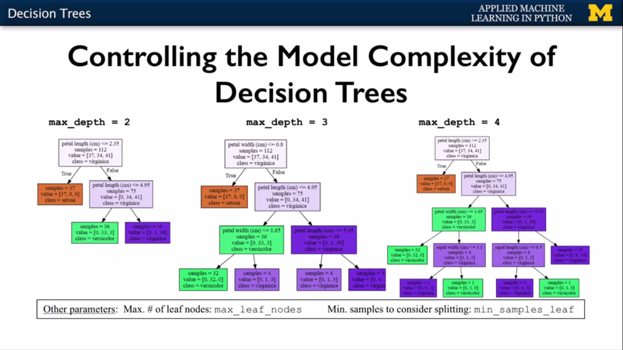

from sklearn.datasets import load_iris

from sklearn.tree import DecisionTreeClassifier

from sklearn.model_selection import train_test_split

iris=load_iris()

X_train,X_test,y_train,y_test=train_test_split(iris.data,iris.target,random_state=3)

clf=DecisionTreeClassifier(max_depth=3).fit(X_train,y_train)

print('Accuracy of Decision tree classifier on train set: {:.2f}'.format(clf.score(X_train,y_train)))

print('Accuracy of Decision tree classifier on test set: {:.2f}'.format(clf.score(X_test,y_test)))

**#setting max decision tree depth to avoid overfitting end here but visualising feature also # continuation**

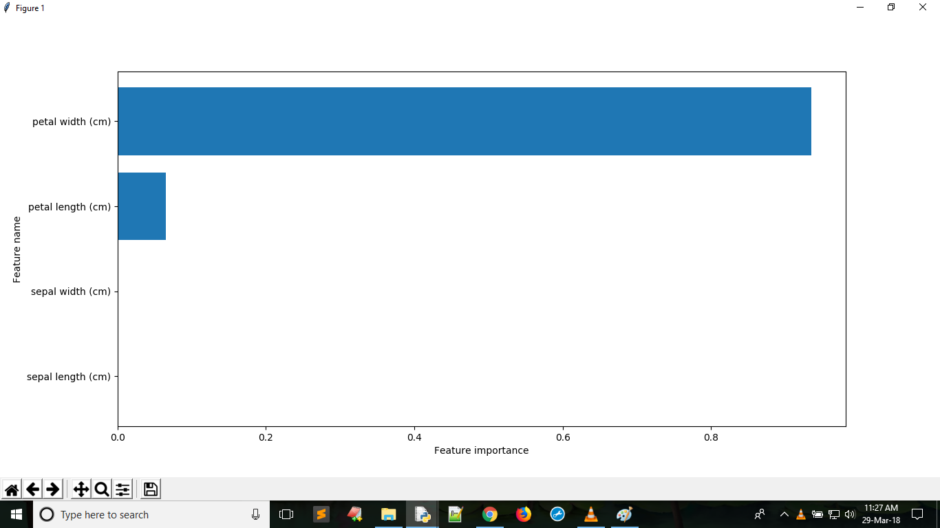

def plot_feature_importances(clf, feature_names):

''' to visualise the feature importance'''

c_features = len(feature_names)

plt.barh(range(c_features), clf.feature_importances_)

plt.xlabel("Feature importance")

plt.ylabel("Feature name")

plt.yticks(np.arange(c_features), feature_names)

plt.figure(figsize=(10,4))

plot_feature_importances(clf,iris.feature_names)

plt.show()

print('Feature importance: {}'.format(clf.feature_importances_))

**#setting max decision tree depth to avoid overfitting end**

**#c3 w2 v12 17:17**

**#Decision tree on real world dataset start**

from sklearn.tree import DecisionTreeClassifier

from sklearn.datasets import load_breast_cancer

**#loading breast cancer data**

cancer = load_breast_cancer()

data = np.c_[cancer.data, cancer.target]

columns = np.append(cancer.feature_names, ["target"])

cancerdf=pd.DataFrame(data, columns=columns)

X_cancer = cancerdf[cancerdf.columns[:-1]]

y_cancer = cancerdf.target

from sklearn.model_selection import train_test_split

X_train,X_test,y_train,y_test=train_test_split(X_cancer,y_cancer,random_state=0)

clf=DecisionTreeClassifier(max_depth=4,min_samples_leaf=8,random_state=0).fit(X_train,y_train)

print('Accuracy of Decision tree classifier on train set: {:.2f}'.format(clf.score(X_train,y_train)))

print('Accuracy of Decision tree classifier on test set: {:.2f}'.format(clf.score(X_test,y_test)))

def plot_feature_importances(clf, feature_names):

"""to visualise the feature importance"""

c_features = len(feature_names)

plt.barh(range(c_features), clf.feature_importances_)

plt.xlabel("Feature importance")

plt.ylabel("Feature name")

plt.yticks(np.arange(c_features), feature_names)

plt.figure(figsize=(10,4))

plot_feature_importances(clf,cancer.feature_names)

plt.show()

print('Feature importance: {}'.format(clf.feature_importances_))

**#Decision tree on real world dataset end**